REACT WEEK 7 HANDSON

1.Create a React Application named “cricketapp” with the following components:

ListofPlayers

* Declare an array with 11 players and store details of their names and scores using the map feature of ES6
* Filter the players with scores below 70 using arrow functions of ES6.

**SOLUTION:**

**ListofPlayers.js**

import React from 'react';

import './App.css';

const ListofPlayers = () => {

  const names = [

    "Jack", "Michael", "John", "Ann", "Elisabeth",

    "Sachin", "Dhoni", "Virat", "Jadeja", "Raina", "Rohit"

  ];

  const scores = [50, 70, 40, 61, 61, 95, 100, 84, 64, 75, 80];

  const players = names.map((name, index) => ({

    name,

    score: scores[index]

  }));

  const below70Players = players.filter(player => player.score < 70);

  return (

    <div style={{ padding: '20px' }}>

      <h2 className="left-align">List of Players</h2>

      <ul className="left-align">

        {players.map((player, index) => (

          <li key={index}>

            Mr. {player.name} - Score: {player.score}

          </li>

        ))}

      </ul>

      <hr />

      <h2 className="left-align">List of Players having Scores Less than 70</h2>

      <ul className="left-align">

        {below70Players.map((player, index) => (

          <li key={index}>

            Mr. {player.name} - Score: {player.score}

          </li>

        ))}

      </ul>

    </div>

  );

};

export default ListofPlayers;

**App.js**

import React from 'react';

import './App.css';

import ListofPlayers from './ListofPlayers';

function App() {

  return (

    <div className="App">

      <h1> Cricket App</h1>

      <ListofPlayers />

    </div>

  );

}

export default App;

App.css

.App {

  text-align: center;

}

.left-align {

  text-align: left;

  margin-left: 40px;

  font-size: 18px;

}

ul {

  list-style-type: disc;

}

**OUTPUT:**

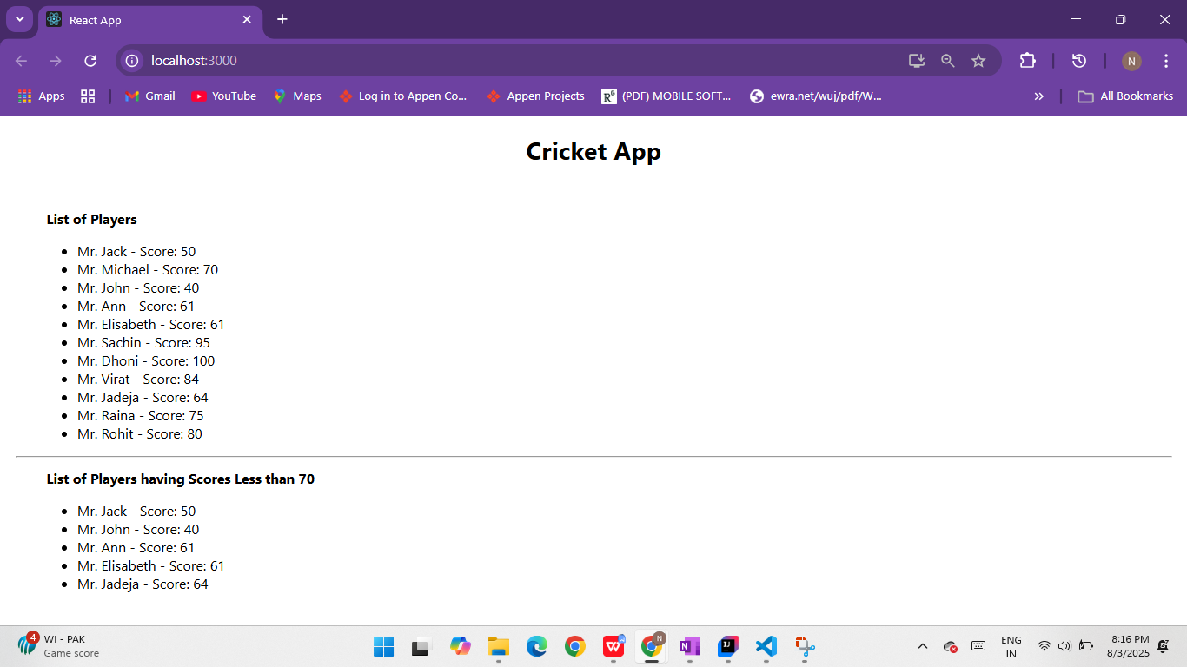

1. IndianPlayers

A.Display the Odd Team Player and Even Team players using the Destructuring features of ES6

B.Declare two arrays T20players and RanjiTrophy players and merge the two arrays and display them using the Merge feature of ES6

Display these two components in the same home page using a simple if else in the flag variable.

**SOLUTION:**

**Components/EvenPlayer.js**

import React from "react";

function EvenPlayers({ IndianTeam }) {

  const [, second, , fourth, , sixth] = IndianTeam;

return (

    <div>

      <p>Second : {second}</p>

      <p>Fourth : {fourth}</p>

      <p>Sixth : {sixth}</p>

    </div>

  );

}

export default EvenPlayers;

**Components/ListofIndianPlayers.js**

import React from "react";

function ListofIndianPlayers({ IndianPlayers }) {

  return (

    <div>

      {IndianPlayers.map((player, index) => (

        <p key={index}>{player}</p>

      ))}

    </div>

  );

}

export default ListofIndianPlayers;

**Components/ListofPlayers.js**

import React from "react";

function ListofPlayers({ players }) {

  return (

    <div>

      {[...players.entries()].map(([name, score], index) => (

        <p key={index}>

          {name}: {score}

        </p>

      ))}

    </div>

  );

}

export default ListofPlayers;

**Components/OddPlayers.js**

import React from "react";

function OddPlayers({ IndianTeam }) {

  const [first, , third, , fifth] = IndianTeam;

  return (

    <div>

      <p>First : {first}</p>

      <p>Third : {third}</p>

      <p>Fifth : {fifth}</p>

    </div>

  );

}

export default OddPlayers;

**Components/Scorebelow70.js**

import React from "react";

function Scorebelow70({ players }) {

  const filtered = [...players.entries()].filter(([name, score]) => score < 70);

  return (

    <div>

      {filtered.map(([name, score], index) => (

        <p key={index}>

          {name}: {score}

        </p>

      ))}

    </div>

  );

}

export default Scorebelow70;

**OUTPUT**

